## **Steering System**

Research Analysis

## Vehicle Dynamics Department

University of Salford Race Team

Introduction

The purpose of this report is to outline the requirements of steering systems in alignment to the 2018 Institute of Mechanical Engineers Formula Student rulebook. Current steering trends from more established teams within the competition have been researched and studied in order to create a base foundation of knowledge and understanding that can be utilised and implemented into Salford Racing’s car design.

**Aims & Objectives**

The ultimate goal is to build a race car that will compete at Silverstone in 2018. One of the most crucial hurdles to successfully overcome is the scrutineering of the finished vehicle; only then can the car take to the track.

The steering system must be:

* Fully functional
* Cost effective
* Lightweight
* Have a satisfactory driver-to-track relationship

These specifications must completed without compromising the overall vehicle performance.

Formula Student Rules 2018

The following information comes from the 2018 rulebook, and is specifically related to the steering, and steering systems of the car, including cockpit design, steering wheel requirements and fastening methods.

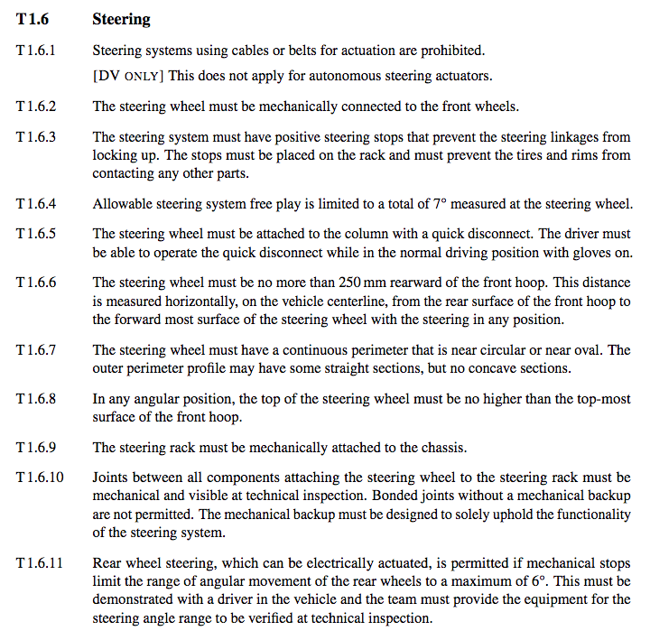

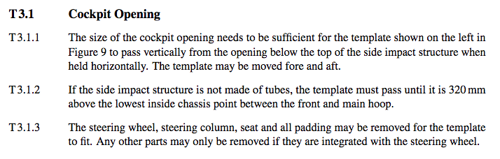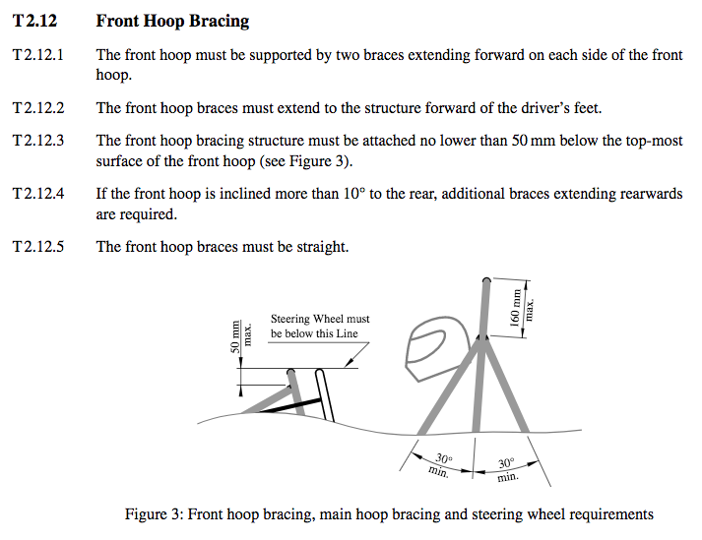

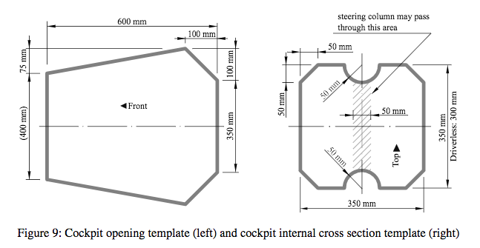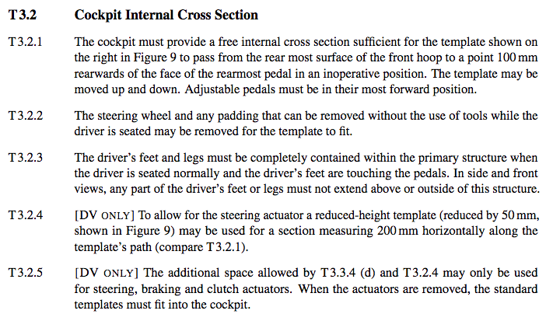

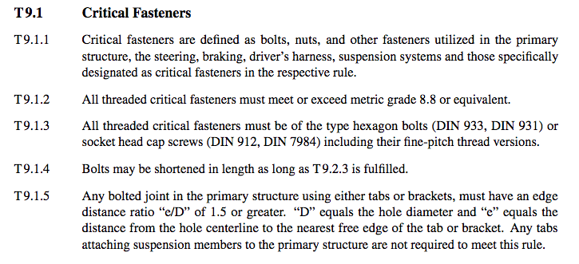

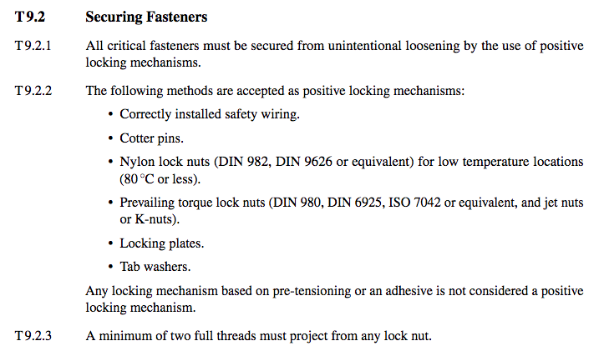

Steering System Failures

According to Formula Student scrutineering teams, there are recurring problems for steering systems within the competition. One of the main issues is the lack of steering column support. This is typically due to the fact that the column only has one support, usually a metal sleeve, which does not cover the steering shaft sufficiently. It has been recommended to use two supports a distance apart as there is likely to be less compliance (elastic deformation). If when force is applied to the steering wheel there is noticeable movement and compliance, the system it is not likely to pass scrutineering.

There has been occasions during scrutineering where cars have been penalised for using incorrect fastening methods, or components have been incorrectly installed. This is not in compliance with the rule book and can have a detrimental effect of the safety of the participants and spectators.

Key Steering System Principles

**General Steering System Components**

Steering systems typically have five main components:

* Steering Box
* Steering Wheel
* Column Shaft
* Knuckle/Upright
* Linkages

Essentially steering systems are a series of pivots, rods, gears and linkages that ensure the wheels are pointed in the required directions depending on the purpose of the vehicle in question.

**Steering Ratio**

This can be defined by the number of degrees turned by a steering wheel to the number of degrees turned by the front wheels. For example, if a system has a steering ratio of 6, every 6 degrees input at the steering wheel will output 1 degree at the front wheels. A greater steering ratio results in the effort required at the steering wheel to turn the wheels is lower.

**Ackermann’s Steering Principle**

This is a geometric steering arrangement calculated to ensure the wheels of a car are able to corner effectively. The purpose of the calculations are to avoid the tyres from losing grip when following a curved path, and so their axles are set as radii with a common centre point. Due to the rear wheels of the car being fixed entities, the centre point is extended from the rear axle. Essentially, it is required that the inside front wheel turns at a larger angle through a corner than the outside wheel.

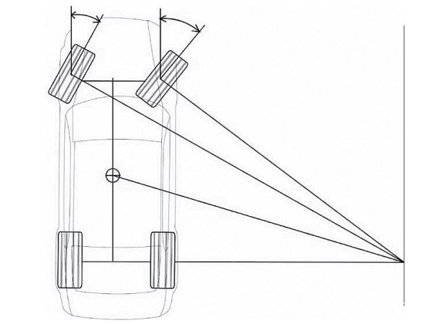

**Force Feedback**

Force feedback allows the driver to gauge how close they are to the cars maximum lateral acceleration, specifically enabling them to feel front axle grip which is essential when cornering at high speeds. This is imperative when creating an effective driver-to-track relationship.

Competitors Designs

**Rack & Pinion Mechanism**

The most popular steering system across the board is the *Rack & Pinion* system. The main reasons for this is its simplicity and low cost. The system consists of the following components:

* Steering Rack
* Pinion
* Tie rods
* Steering Shaft/Column

A metal tube encloses the rack and pinion, where the rack protrudes from either end with connecting tie rods attaching to the wheels. A steering shaft is then connected to the pinion gear which allows for rotary motion from the turning of the steering wheel to be transferred into linear motion in the steering rack.

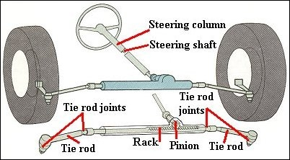

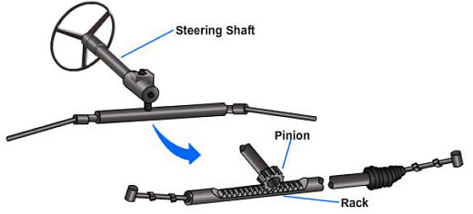

Many teams with the facilities to do so have designed and manufactured their own components, others have opted to buy complete packages. These complete packages range in price, specifications and performance.

**Advantages**

* Gives the driver a better overall feel of the car compared to other available steering systems.
* Cheap.
* Simple design.
* Lightweight.
* Robust.
* Compact.
* Tie rods can be directly secured to the wheels.

**Disadvantages**

* No mechanical advantage.
* Some steering exertion is lost in friction.
* Sensitive to impact.
* Some steering wheel disturbance can be felt, especially in front wheel drive vehicles.

Overview

In conclusion to the initial research conducted, it is suggested that the dynamics team begin designing a rack and pinion steering system. As a young Formula Student race team, this is the most logical option, as it will allow for the team to create a foundation to build on for the future, while ensuring the car can compete this season. As the team learn more about the car and the competition the system can be adjusted and upgraded accordingly to increase performance and efficiency.

The next steps for the vehicle dynamics team should be:

* Confirm chassis design and specifications.
* Discuss the overlap of the steering system with the suspension team.
* Decide what parts and components are to be designed, sourced from inhouse resources, or bought.
* Research material for any components that are to be designed.
* Create a database for required components. This can be added to as and when needed.
* Conduct initial research on calculations and geometry.
* Discuss budget with engineering leads.